Pharmacy Padlock

Padlock will be showing because there are unanswered exceptions.

It appears you have looked a patient up, and not dispensed to that patient within the 12 hours either side of viewing the patient record.

To get past the padlock, you will need to go to the ‘home’ button (in the top of the blue menu bar on left of their screen).

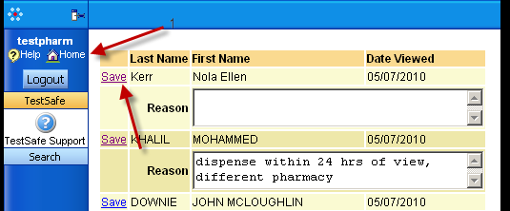

You will then be presented with a windowlet – which is like a dialog box that pops up, similar to above.

When you have filled in the reason for the access, press the save button, and the exception will disappear.
When all exceptions are gone, and you are presented with a message saying ‘ no outstanding exceptions found’, you will have unlocked your system,
And will be able to access patient records once again.

